**SAP ABAP – Assignment Week 1**

**DATA TYPES AND DATA OBJECTS:**

**Input:**

**Output:**

**CONTROL STATEMENTS:**

**Input**

**Output:**

**STRINGS**

**Input:**

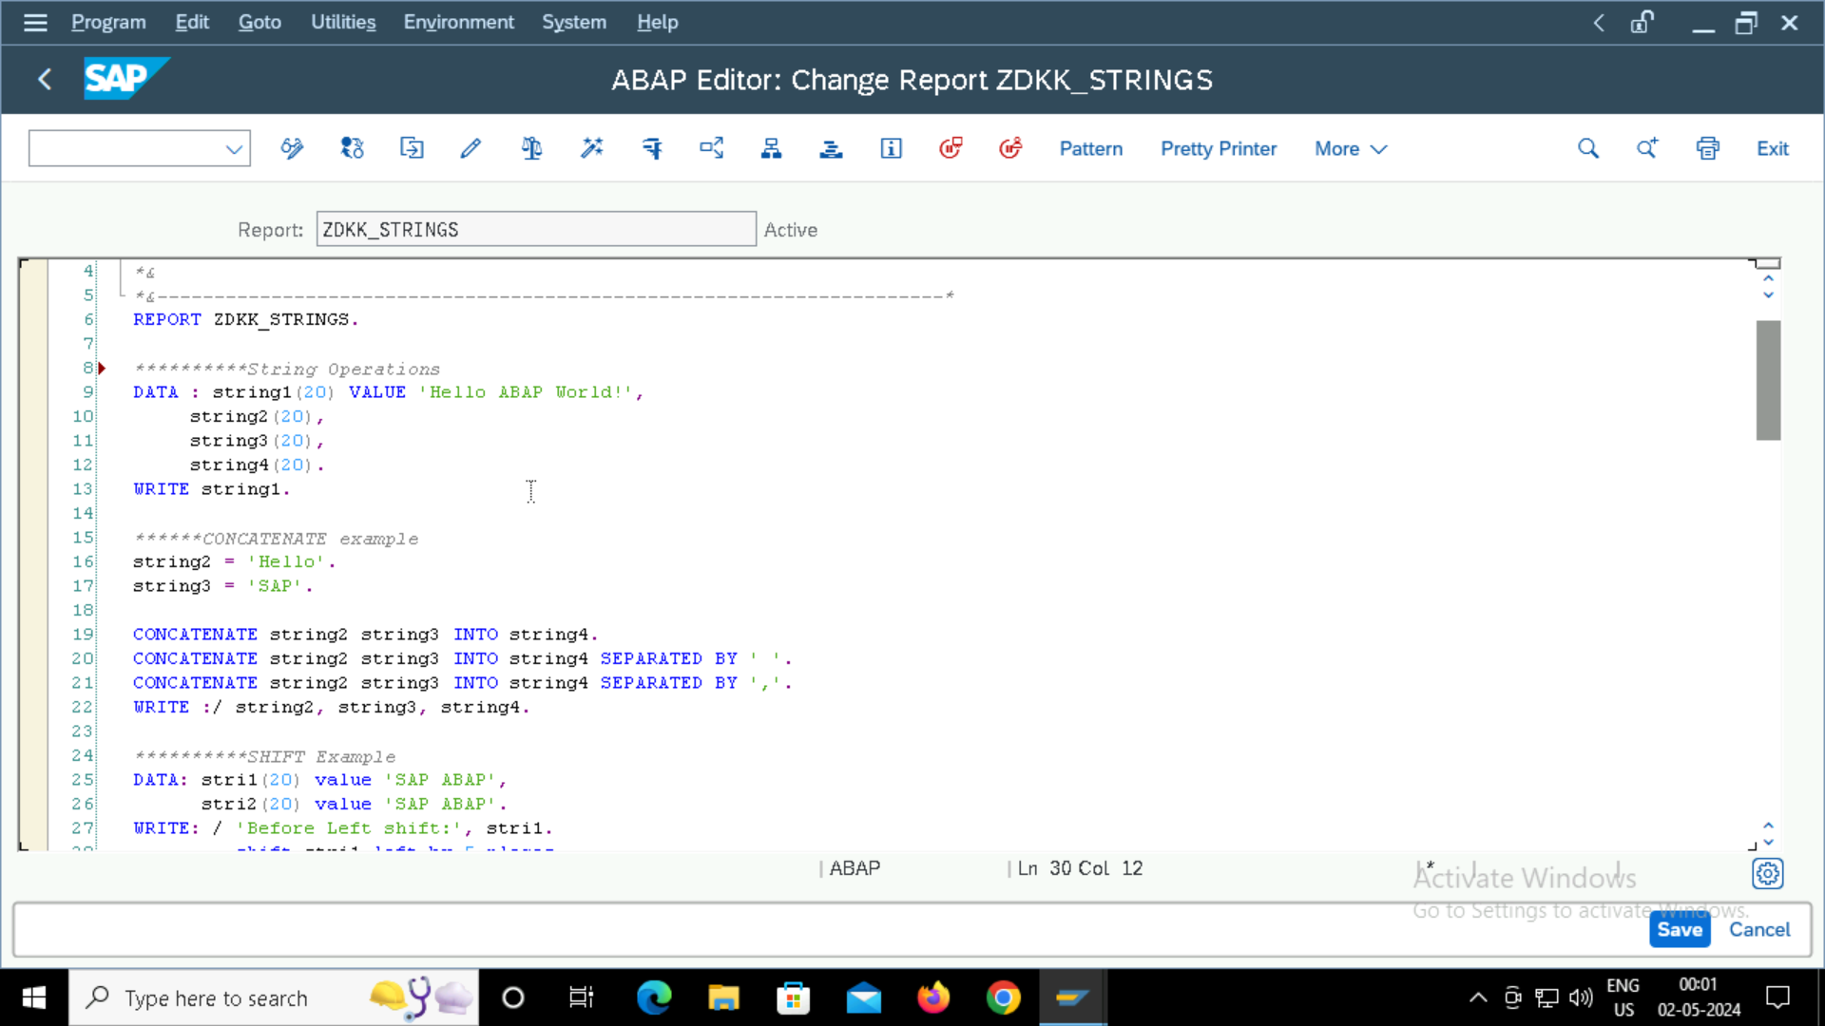

**Output:**

**Output**

**TABLES creation in ABAP:**

**Input Table Entries:**

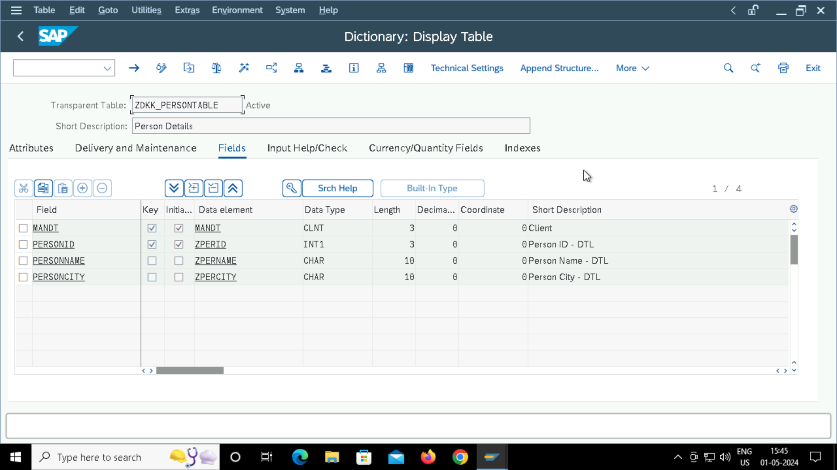

**Output Table Contents:**

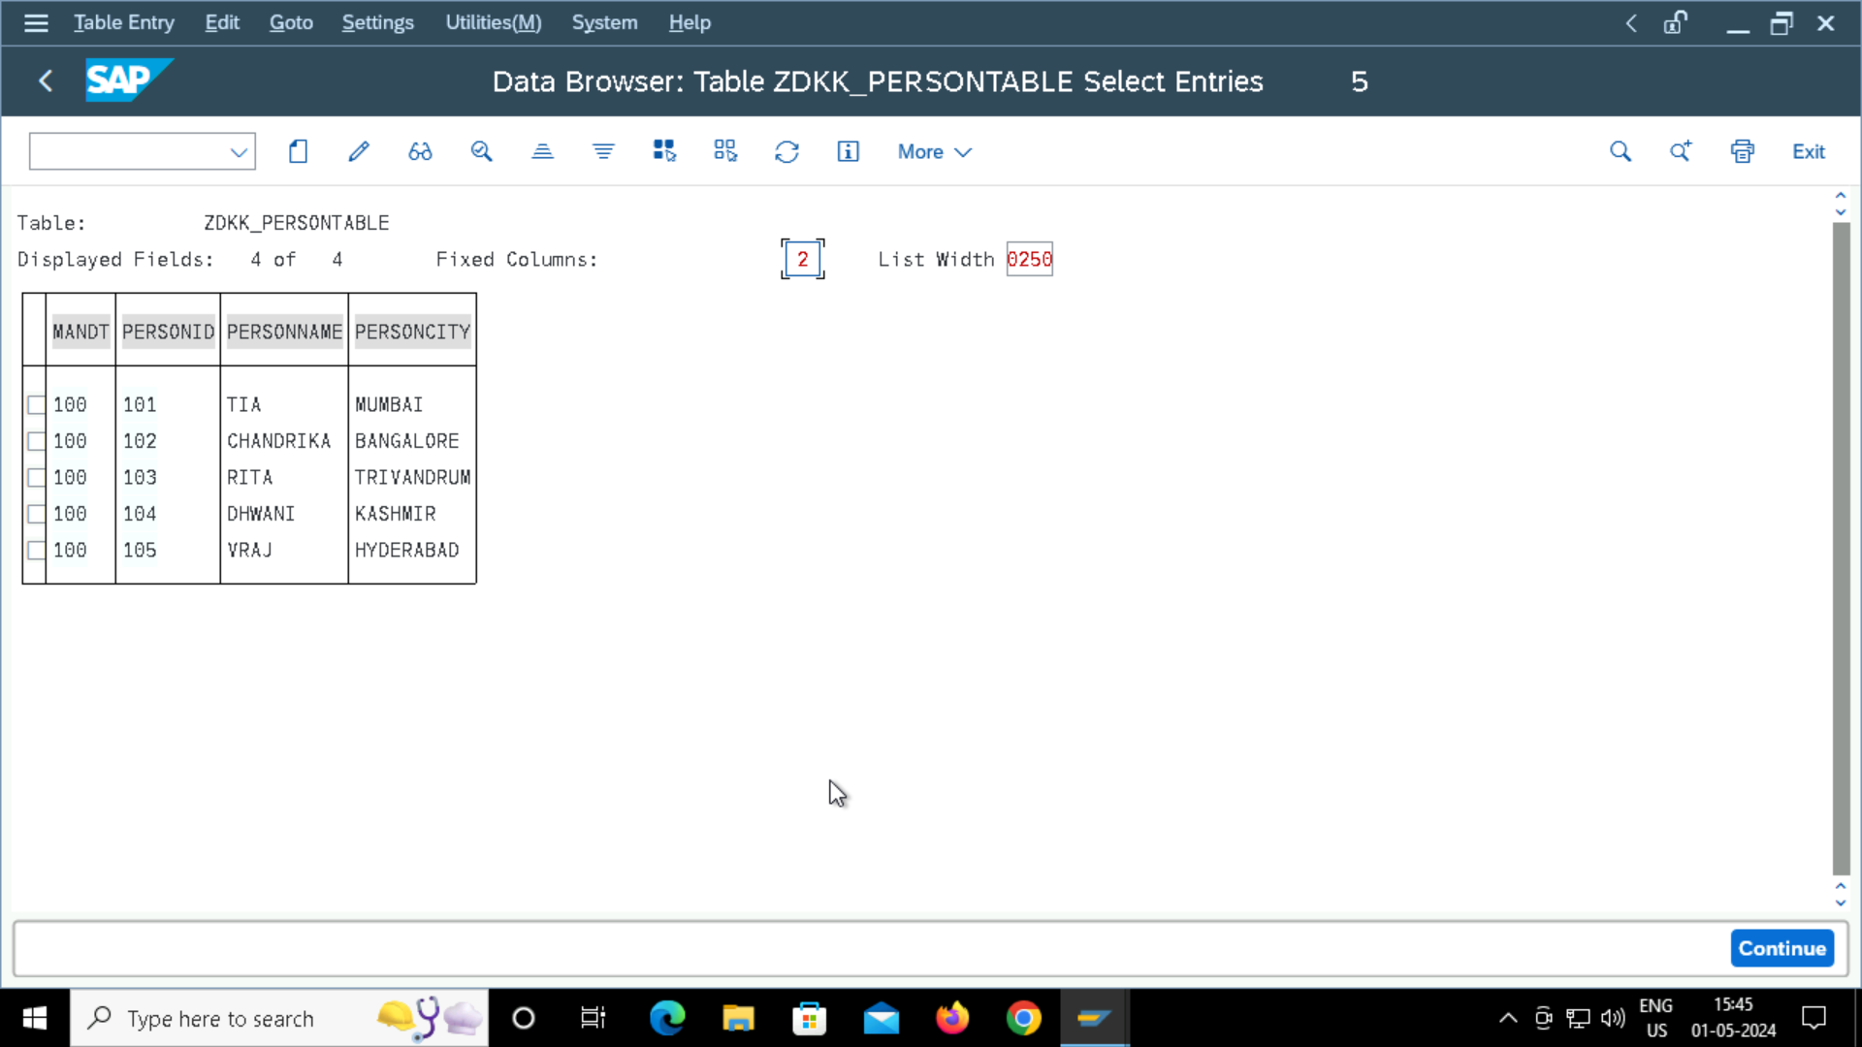

**INTERNAL TABLES:**

**Input:**

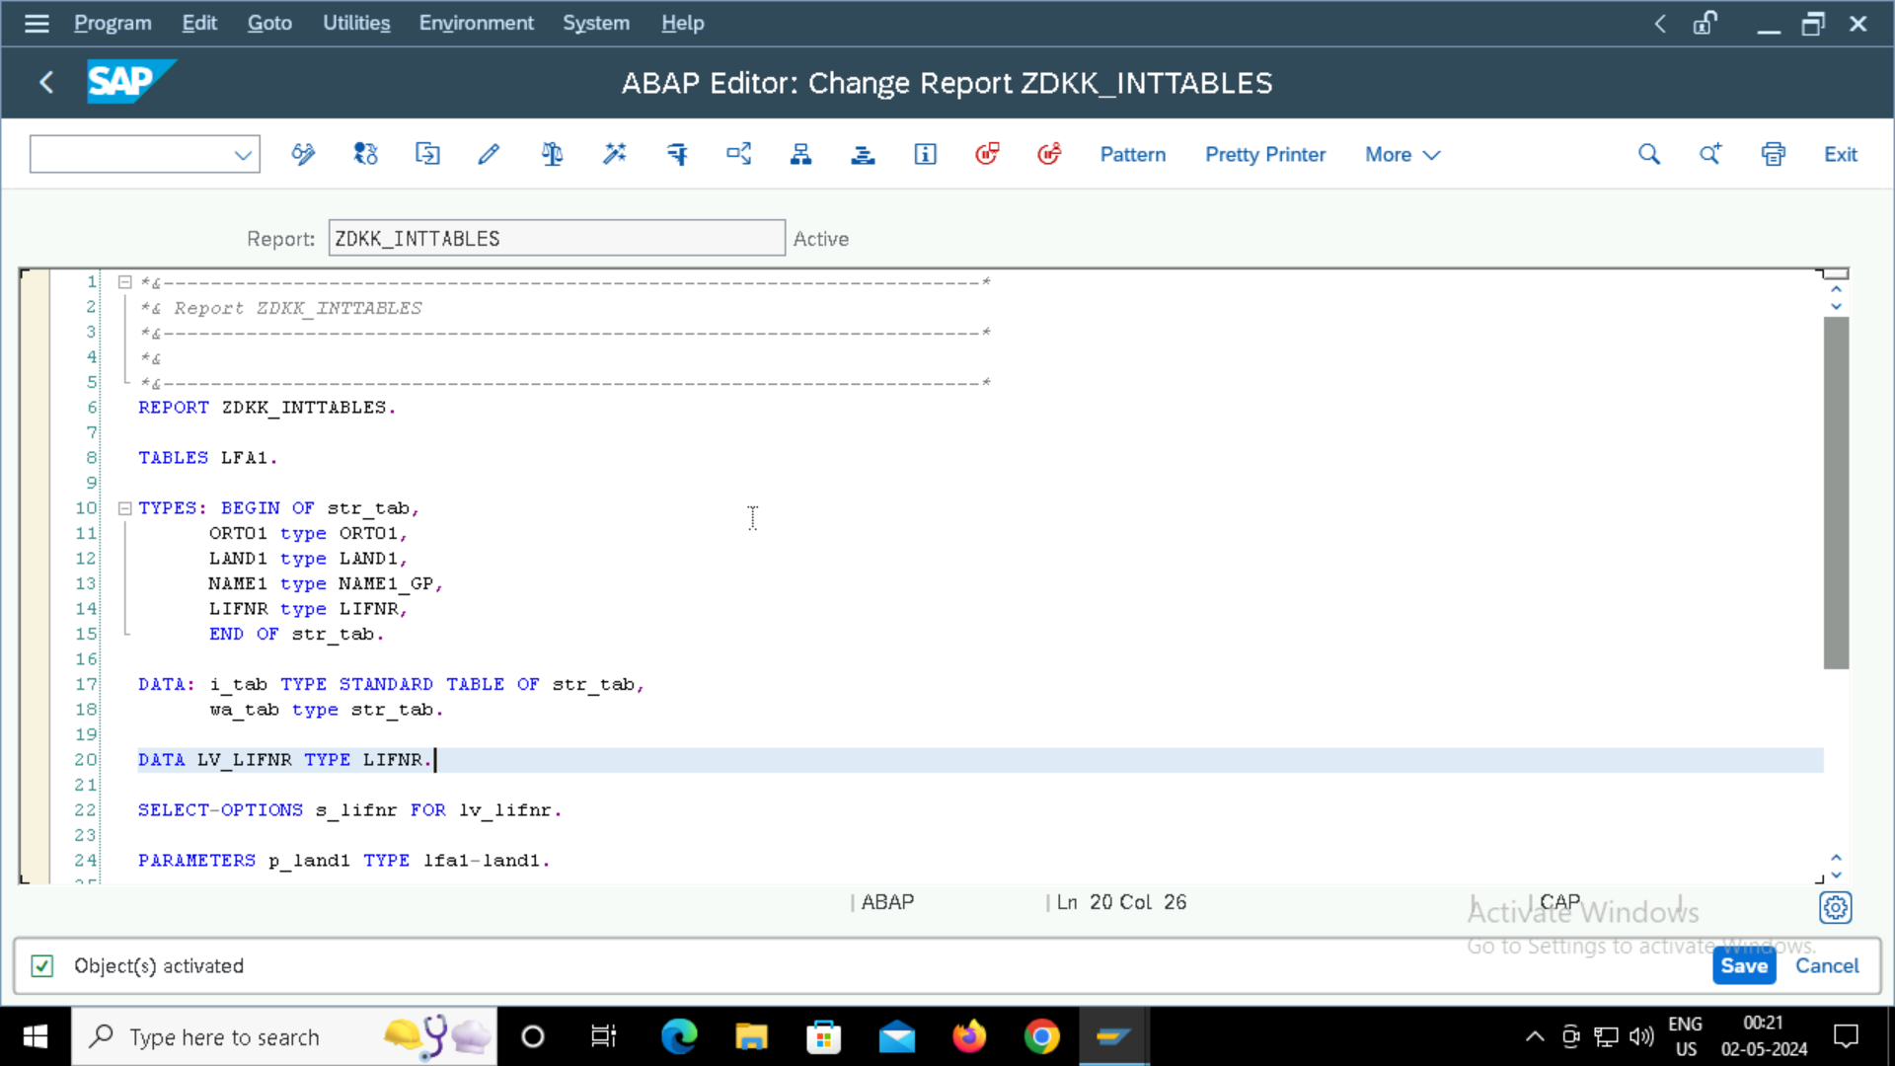

**Output:**

**FOREIGN KEYS:**

Employee Table is Check Table. Foreign Key is created in Dept Table.

**Input:**

**Output:**

**STRUCTURES:**

1. **Flat Structure**

**Output**

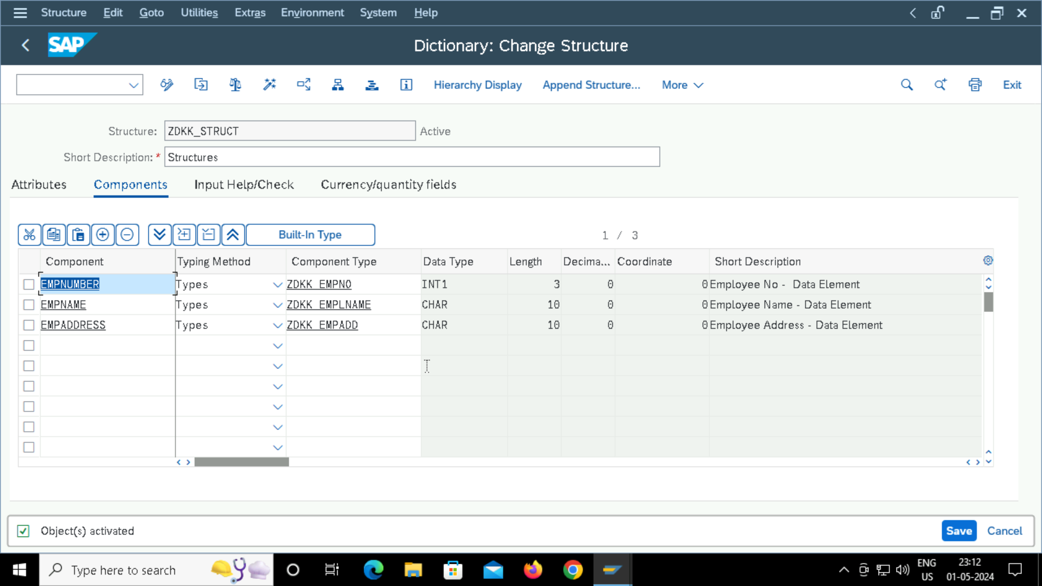

1. **Complex Structure/ Line Type**

**Output**

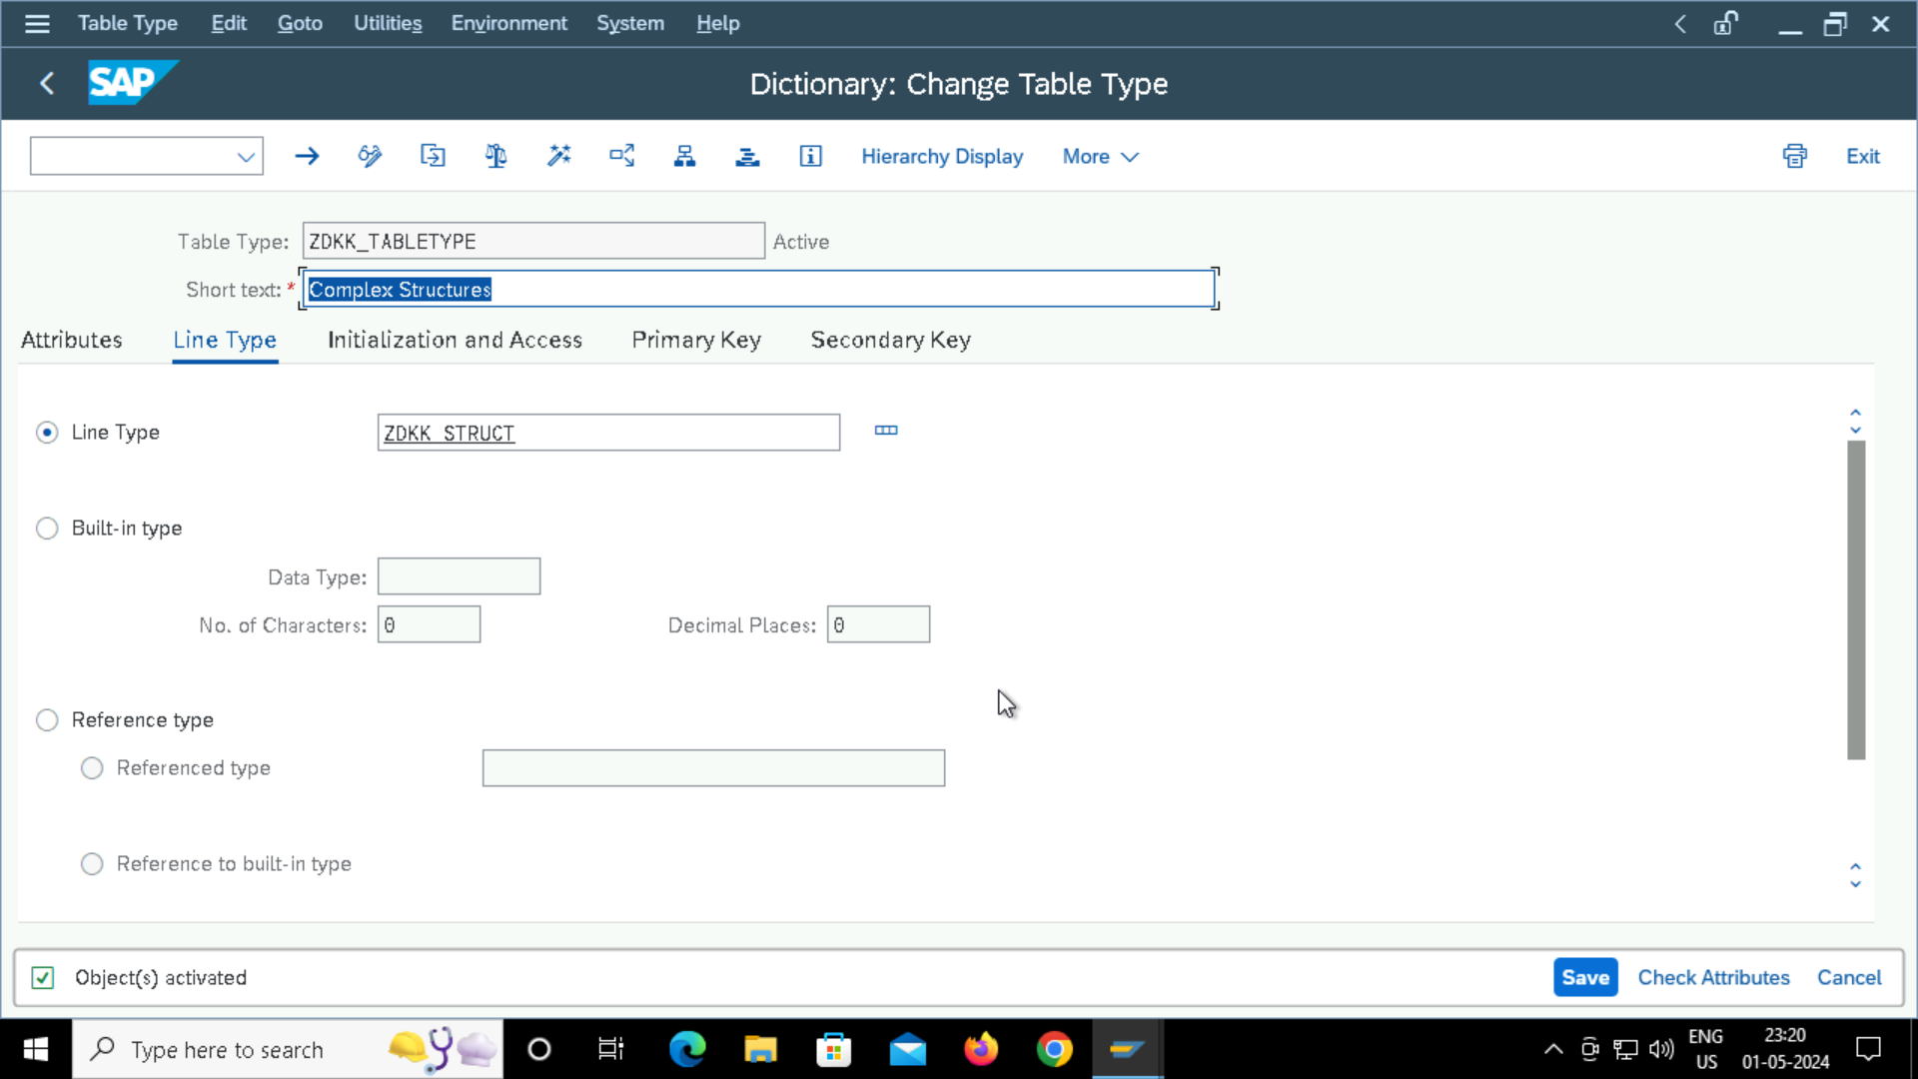

**DATABASE VIEW**

Input:

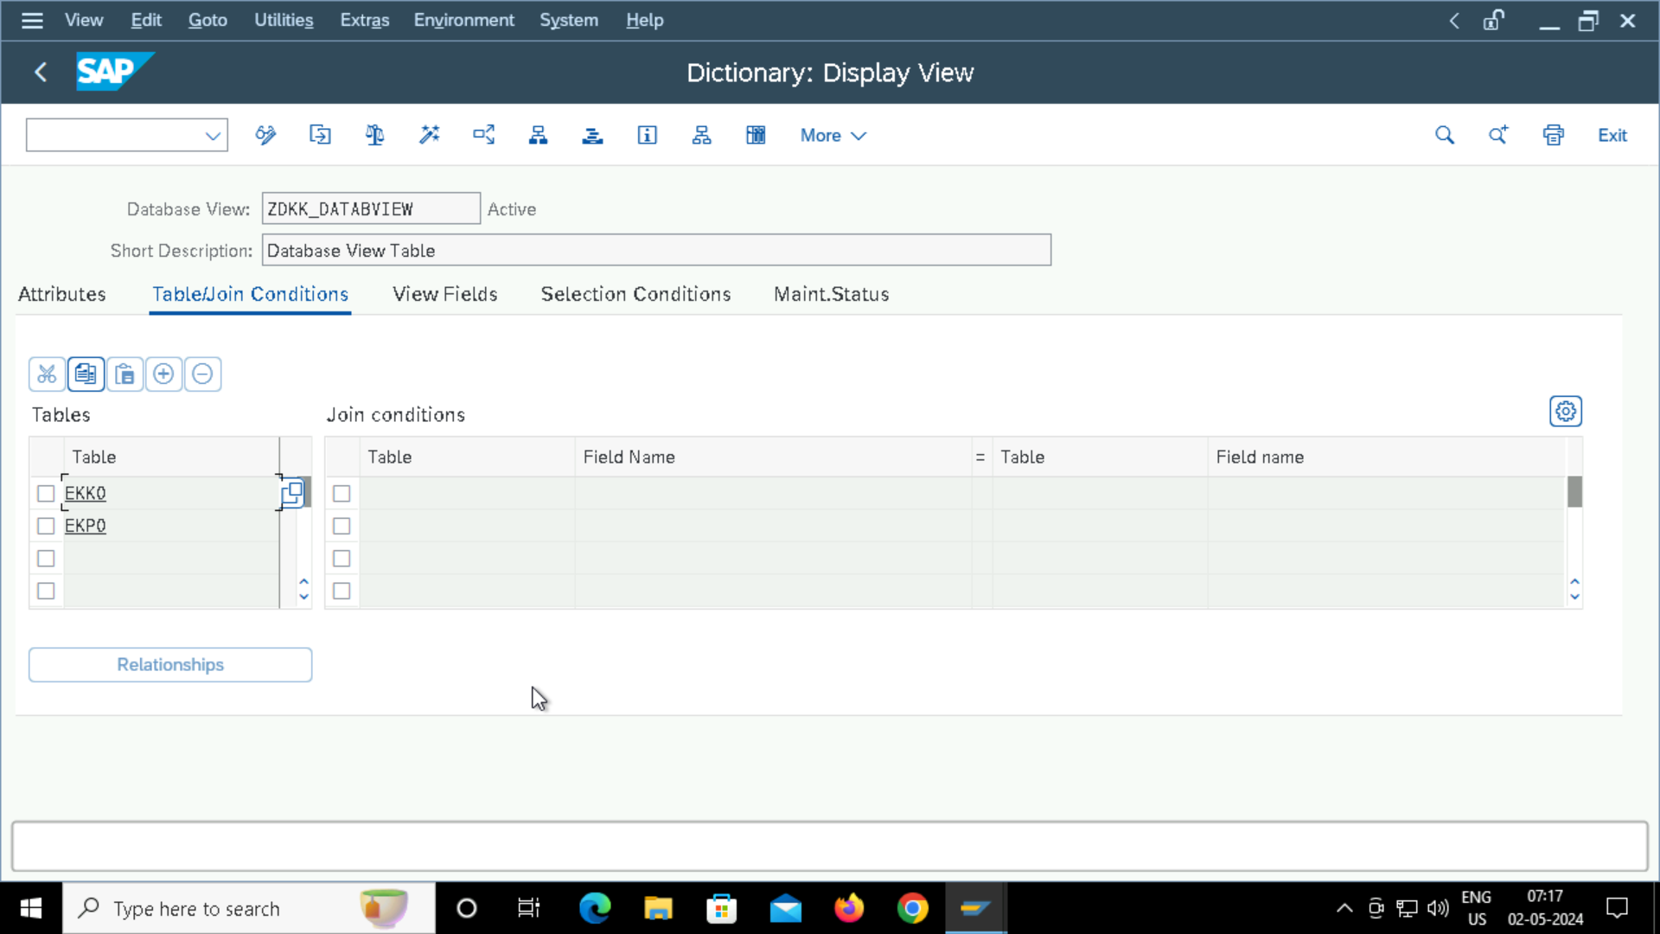

**INNER JOINS:**

Tables used: EKKO and EKPO

**Input Code: 3 codes**

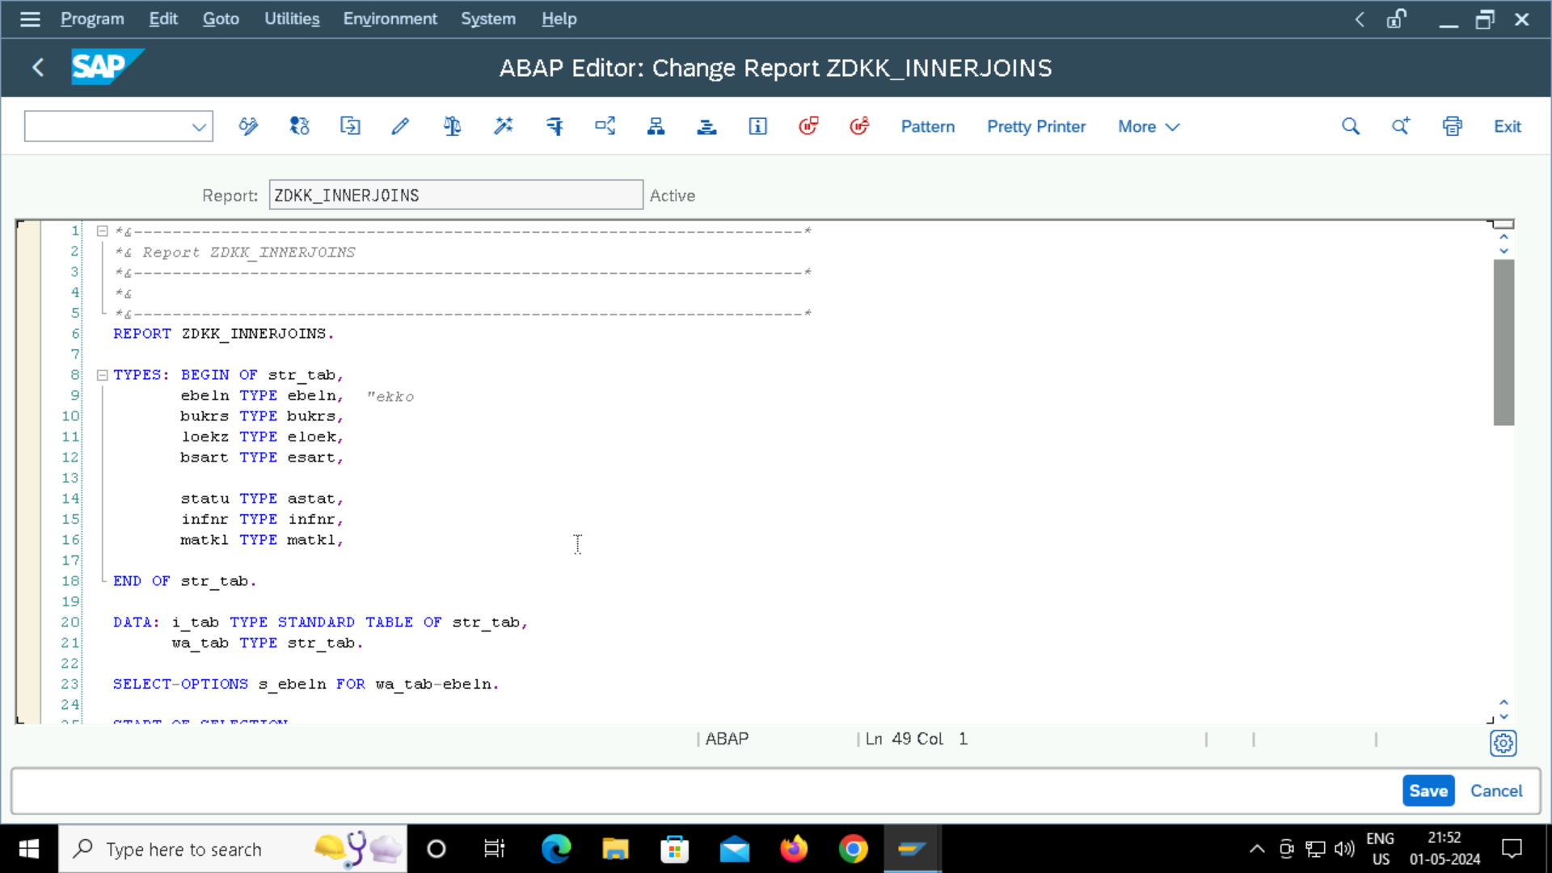

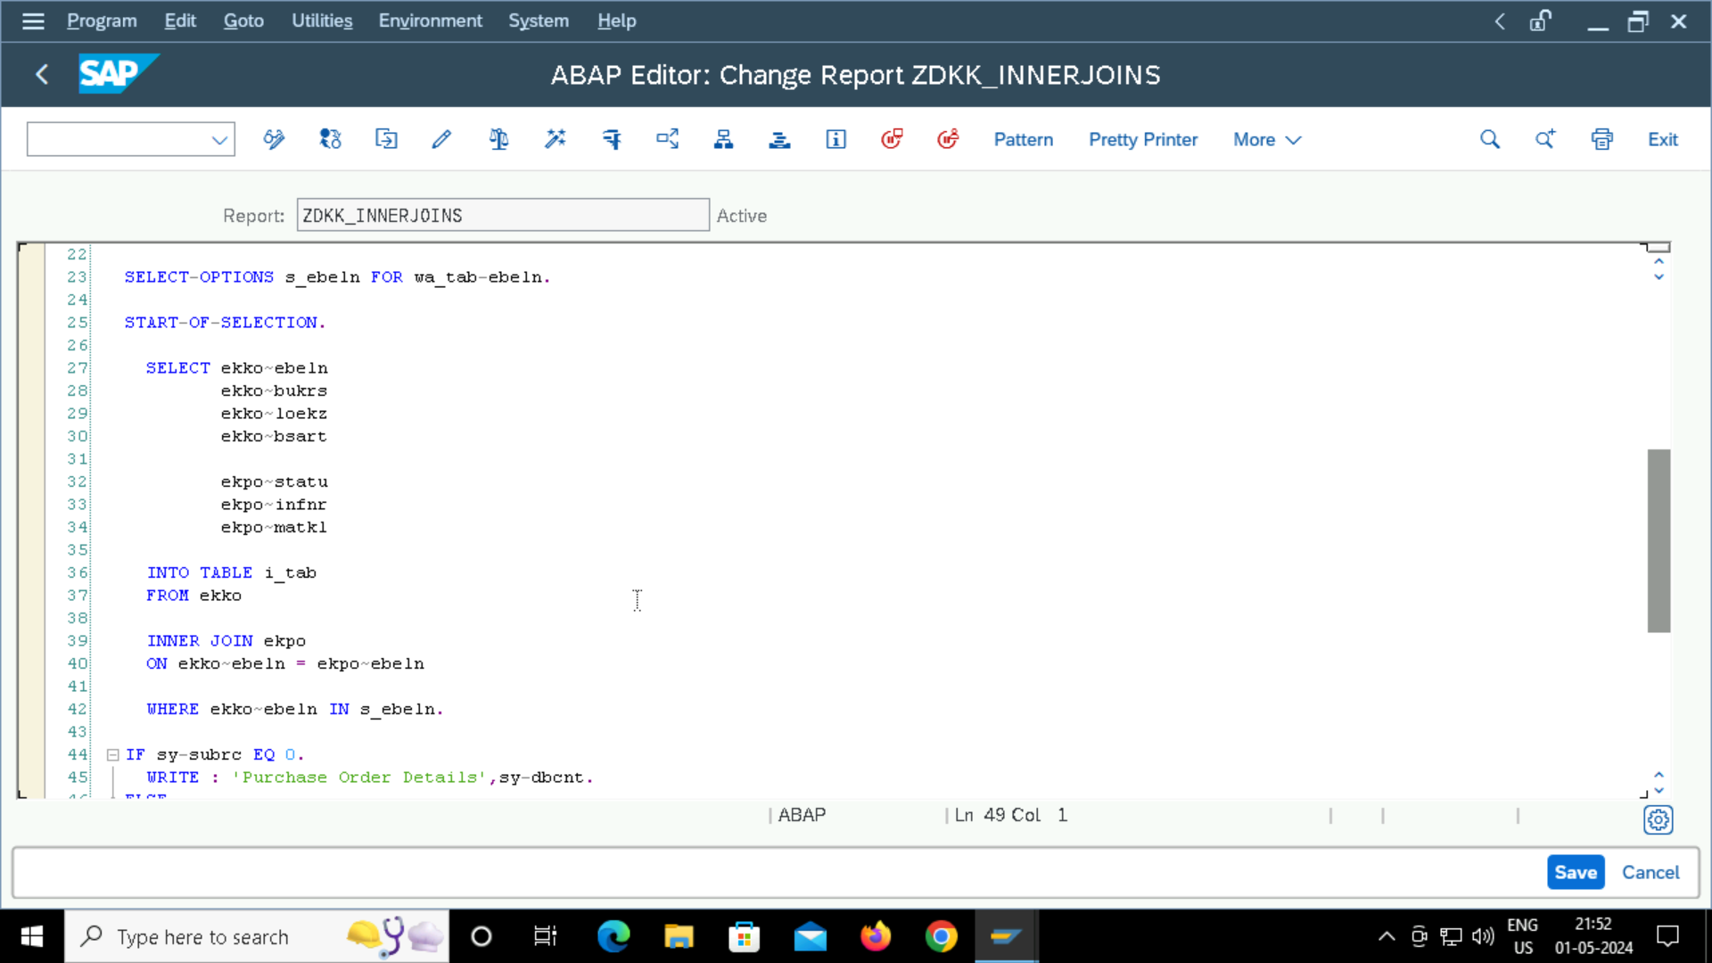

**Output Code:**

